IMPROVEMENT ON THE DESIGN AND CONSTRUCTION OF A BEANS THRESHING MACHINE

BY
FRANCIS OLUWAMAYOWA ADIO FPTB/MET/HND/19/134082
SALMA MICHEAL FPTB/MET/HND/19/131323
HARUNA TISHAK MANASSEH FPTB/MET/HND/19/131320
BILIYAMINU MANZO FPTB/MET/HND/19/136027
GOODWILL AGWOM PATE FPTB/MET/HND/19/133042

A PROJECT REPORT SUBMITTED IN PARTIAL FULFILLMENT OF THE REQUIREMENTS FOR THE AWARD OF HIGHER NATIONAL DIPLOMA (HND) IN MECHANICAL ENGINEERING TECHNOLOGY

DEPARTMENT OF MECHANICAL ENGINEERING TECHNOLOGY
SCHOOL OF ENGINEERING TECHNOLOGY
FEDERAL POLYTECHNIC, BAUCHI

SEPTEMBER, 2022
DECLARATION
We hereby declare that this project was written by us and it is the record of our own research work. No part of this project report was previously presented elsewhere for a Degree or Higher National Diploma. References made to published literatures have been duly acknowledged.
Francis Oluwamayowa Adio ……………………………………….
(STUDENT) SIGNATURE/DATE

Salma Michael ……………………………………….
(STUDENT) SIGNATURE/DATE

Haruna Manasseh Tishak ………………………………………. (STUDENT) SIGNATURE/DATE

Biliyaminu Manzo ……………………………………….
(STUDENT) SIGNATURE/DATE

Goodwill Agwom Pate ……………………………………….
(STUDENT) SIGNATURE/DATE

The above declaration is confirmed by
Engr. Shuaibu Balogun ……………………………………….
(SUPERVISOR) SIGNATURE/DATE

Mr. Ibrahim Babangida ……………………………………….
(SUPERVISOR) SIGNATURE/DATE
CERTIFICATION
This project report title “Improvement on the Design and Construction of Beans Threshing MachineFrancis Oluwamayowa Adio, Salma Micheal,Tishak Manasseh Haruna,Biliyaminu Manzo and Goodwill Agwom Pate meets the regulations governing the award of Higher National Diploma (HND) of the Federal Polytechnic, Bauchi and is approved for its contribution to knowledge.
Engr. Shuaibu Balogun ……………………………………….
(SUPERVISOR) SIGNATURE/DATE

Mr. Ibrahim Babangida ……………………………………….
(SUPERVISOR) SIGNATURE/DATE

Engr. Abubakar M. Aliyu ………………………………..…….
(PROJECT COORDINATOR) SIGNATURE/DATE

Engr. Alhassan A. M ………………..……………………..
(HEAD OF DEPARTMENT) SIGNATURE/DATE

…………………..................... ……..………………………………..
(EXTERNAL EXAMINER) SIGNATURE/DATE

DEDICATION
This project is dedicated to Almighty God, our parent, Lecturers, Friends and Families for their total support during this program.
ACKNOWLEDGMENTS
We thank the Almighty God and we are grateful and would like to express our sincere gratitude to our able, capable and also the capacitated Project Coordinator (Engr. Abubakar M. Aliyu) for his germinal ideas, invaluable guidance, continuous encouragement and constant support in making this project possible. He has always impressed us with his outstanding professional conduct, his strong conviction for engineering, and his belief that Higher National Diploma program is only a start of a life-long learning experience. We are truly grateful for his progressive vision about our training in engineering, his tolerance of our naive mistakes, and his commitment to our future career. We acknowledge our sincere indebtedness and gratitude to our parents for their love, dream and sacrifice throughout our life. We cannot find the appropriate words that could properly describe our appreciation to the Head of Department, Mechanical Engineering and also our supervisor in person of (Engr. Alhassan A. M) for his devotion, support and faith in our ability to attain our goals. Our sincere thanks go to our supervisors (Engr. Shuaibu Balogun) and (Mr. Ibrahim Bbabangida) for their support and encouragement as well as members of the staff of the Mechanical Engineering Department, and our classmates who helped us in many ways and made our stay at Federal Polytechnic, Bauchi pleasant and unforgettable.

TABLE OF CONTENTS
Title page………………………………...………………………………………...………......i
Declaration…………………………………..…………………………….….……..…….......ii
Certification……………………………...………………………………….………..…........iii
Dedication…………………………………………………………………………….….…...iv
Acknowledgments..……………………………………………..........................................v
Table of Contents…………………………..………………………………...............................vi
List of Figures……..…………………………………………………………...........................vii
List of Plates…………...……………………………………………………….........................viii
Abbreviations……......…………………………………………………………………………ix
Greek Symbols…………………………..…………………………….................................x
Abstract…..…………………………...…………..…………………..................................xi

CHAPTER ONE
- INTRODUCTION………………...…………………………………….…………………1
1.1 Background of the Study………….…………………...……………….………………..1-5
1.2 Statement of Problem……………………………….…………………………….………..5
1.3 Aims and Objectives……………….………………………………..……………………..5
1.3.1 Aim …….…………….………………………………….…..….…….............................5
1.3.2 Objectives……………….…………….………………………...……………...………...5
1.4 Significance of the Study……………….………………………………………….……....6
1.5 Scope of the Study……………………….…………………………………………….…...6
CHAPTER TWO
2.0 LITERATURE REVIEW………………….………………………………………………7
2.1 Introduction………………………………….…………………………………………….7
2.2 Historical backgroung of thresher…………………………………………………………7
2.2.1 Design of input unit of thresher……………………………………………………….10
2.2.2 Construction of grain threshers……………………………………………………..…10
2.2.3 Main component of thresher…………………………………………………………..11
2.2.3.1 Spike tooth type……………………………………………………………………...12
2.2.3.2 Rasp bar type cylinder ……………………………………………………………..13
2.2.3.3 Wire loop type cylinder…………………………………………………………….14
2.2.3.4 Cutter blade type cylinder………………………………………………………….16
2.2.3.5 Hammer mill type cylinder…………………………………………………………16
2.2.4 Concave……………………………………………………………………………….16
2.2.4.1 Screen type concave………………………………………………………………..17
2.2.4.1 Perforated concave………………………………………………………………….17
23 Performance Evaluation……………………………………………………………….…17
2.4 Analysis of Literature Review…………………………………………………………...19

CHAPTER THREE
3.0 DESIGN THEORY AND ANALYSIS………………………………….…………….. 20
3.1 Design Theory…………………………………………………………….……………...20
3.1.1 Design theory for beans thresher ……….……………..……………………….......…20
3.1.1.1spike tooth type………………………….………………………...……..................21
3.1.1.2 rasp bar type cylinder………………….…..…………………………………………22
3.1.1.3 wire loop type cylinder ………………………..……………................................23
3.1.1.4 hammer mill type cylinder……..…………....……………..……………………..24
3.2 Design Analysis……………………………………………………..…………….......25
3.2.1 Conceptual design……………………………………………………………………25
3.2.1.1 the hopper…………………………………………………………………….……25
3.2.1.2 threshing chamber………………………………………………………………….26
3.2.1.3 the screening unit………………………………………………………………..…26
3.2.1.4 the cleaning unit……………………………………………………………………27
3.3 Material Selection………………………...………………………..………………….28
3.3.1 Detail design………………………………………………………………………….28

CHAPTER FOUR
4.0 MANUFACTURING PROCESSES…..…………………..........…………………………51
4.1 Main Components Manufactured.…………………………...……………………….…..51
4.1.1 Hopper............………………..………..……………………...……………………......52
4.1.2 Threshing Chamber……………….……….…………..…………………..………….…52
4.1.3 The blower……..…………………………………………………………..……..….…..52
4.1.4Bolts and nut………………………..……………………………………….……………53
4.1.5 V-belts ………………..….…….………………………….……….………....................53
4.1.6 Threshing chamber………………..………..…………………………………………..…54
4.1.7 Concave screen………….……………………………………….………………....……..54
4.1.8 Pulley, bearing and housing…..……….………………………………………………....54
4.1.9 Frame……….…….……………………………………………………………………….55
4.2 Tools and Equipment……………………….…………...…..……………………………..55
4.2.1 Tools……………………………………….……………...………………………………55
4.2.2 Equipment…………………………………………………..…………………………….62
4.3 Operation Sequence…………………………………………………………………….......62
4.4 Assembly…………………………………..……………………………..........................65
4.4.1 Types of assembly…………………………………..………………………………….65
4.4.2 Welding………………………………………………..……………………………….65
4.4.3 Bolting…………………………………………………...…………….........................66
4.4.4 Finishing…………………………………………………...………………………...…66
4.5 Bill of Engineering Measurement Evaluation (B.E.M.E)……………………………......66
4.5.1 Material cost (A)…………………………………………………………....................67
4.5.2 Labour cost (B)………………………………………………………………………....68
4.5.3 Overhead cost (C)……………………………………………………………………....68
4.6 Test and Results.……………………………………………………………………………69
4.6.1 Test……………………………………………………………………………………….69
4.6.1.1 No Load threshing manchine test…………...……………….……………….............69
4.6.1.2 Load threshing machine test………………….……………………………………….69
4.6.2 Results………………………………………………………………………………..…..70
4.7 Discussion of Results…...……………………………………………………………...…70
CHAPTER FIVE
5.0 SUMMARY, CONCLUSION AND RECOMMENDATIONS…..………………………72
5.1 Summary………………………………………………………………………………….72
5.1 Conclusion………………………………………………………………………………...72
5.2 Recommendations………………………………………………………………………...73
References………………………………………………………………………………..…74-75
Appendix I: Beans threshing machine ……………………………………………………....
Appendix II: Exploded Drawing…………...……………………………………………....
Appendix III: All views ……………………………………...……………………………

LIST OF FIGURES
Figure 1 peg tooth type……………………….………………………….…………………13
Figure 2 raspbar type………………………………..……………………...………………14
Figure 3 wire loop type……………………………………..………………..…………….14
Figure 4 hammer mill type………………………………………..………….…………….16
Figure 5 peg tooth type………..……………………………………………………………22
Figure 6 raspbar type…………………………………………………………………….....23
Figure 7 wire loop type…………………………………………………………….……….24
Figure 8 hammer mill type…………………………………………………………..…..….25
Figure 9 hopper ………………………………………………………………….…………26
Figure 10 the screening unit………………………………..……………………………..27
Figure 11 Scriber……………………...………………………….………………………56
Figure 12 Hack saw………………..…………………………………….……………….57
Figure 13 Hammer……………………………………………………………..………….57
Figure 14 Spanner……………………………………………………….………………..58
Figure 15Screw driver………………………………………………………….…….…..58
Figure 16 Drilling machine………………………………………………………….……59
Figure 17 cutting machine………………………………………………………...…..…59
Figure 18 Spraying (painting) machine………………………………………………….60
Figure 19 Arc welding machine………………………………………..………….……..61

ABBREVIATIONS
mm Millimeter
m Meter
L Length
rpm Revolution per minute
rad Radians
W Watts
T Torque
J Polar second moment of area
G Modulus of Rigidity
V Linear Velocity
Kg Kilogram
P Power
r Radius
N Number of Revolution
i Number of rows of balls in any one bearing,
Z Number of balls per row
d Diameter
T Thickness of weld
V Volt
I Current
T Number of gear teeth
GREEK SYMBOLS
$τ$ Shear stress
$θ$ Angle of twist
$ω$ Angular velocity
$π$ Pie
$α$ Nominal angle of contact
$f_{0 }$ Factor depending upon the type of bearing.
$S_{CF}$= Stress concentration factor
₦ Naira
% Percentage
& And

Abstract
Post-harvest losses are due to bean threshing and this because many farmers still prefer the traditional method of threshing over the mechanical method since the mechanical method has a large breaking efficiency that cannot be overlooked. Thus, low quality beans are being produced and time of distribution is limited. In this study, the aim and objectives is to improve on the design and construction of a bean threshing machine. Focusing mainly on the threshing and cleaning efficiency. The input efficiency too was also redesigned. This would increase the productivity. The redesigned input unit increased the throughput which choked up the threshing chamber. Rubber hammer was used in the hammer mill hereby reducing breaking efficiency. Fan blower was used in the cleaning unit which is attached to an inclined plane collector which blows off the chaff since it is light weighted. The machine recorded a threshing efficiency of 95%, 3% breakage efficiency and 60% cleaning efficiency at a seed moisture content of 12%. The design of the various machine parts was carried out by analyzing forces on them which led us to selection of proper materials to withstand the forces to avoid failure.

CHAPTER ONE
1.0 INTRODUCTION
1.1 Background of Study
A threshing machine is a power driven or manually operated agricultural machine used to separate the seed of the harvested plant from its straw. Threshing is done by removal of beans. From the pod using motorized machine. Bean threshing is a major step in grain preparation after reaping (Henry, 2019).
Earlier designs of threshing machine were to be manually driven or trampling by animal hooves and these varies from thresher to thresher. Because a thresher for maize had a different design to a bean thresher but the agricultural operation was mostly similar.
The major components of the machine include the threshing, separation and cleaning unit. The threshing operation is achieved by rotational motion of the cylinder fitted with beater pegs above a stationary grid which result in the removal of the seeds from the particle and then separation from the straw. (Farm machinery and equipment).
The input unit is also a major part of the machine because it is used to feed the machine. Input unit varies from thresher to thresher. Each type of machine input also determined throughput efficiency of such machine. Threshers are common with the throw-in type of feeding unit; the un-threshed grain is pushed into the threshing cylinder (Gbado et al 2013). A good feeding unit increases machine efficiency and avoid many injuries during threshing processes (farm machinery and equipment). The feeding unit is always constructed attached to the threshing chamber with an open at the top for proper feeding.
Generally, hopper type of feeding unit has rotating star wheel mechanisms between the hopper and threshing drum to facilitate the uniform feeding of crop to the drum (Mahmoud et al 2007). Millet thresher employs the use of trapezoid shape hopper made of mild steel. Cowpea threshers also uses a hopper but in this case, it is a frustum shaped hopper made also of mild steel (Yamba et al 2017). It can be observed that every thresher has a different hopper that will help in its discharge rate.
Threshing unit is the major part of every threshing machine. It carries out the most important duty the machine was built for. This unit has a rotating star wheel mechanism that consist of either a rasp bar, peg, fallen hammer, etc. that will be used to thresh the grain based on its properties (Chaturvedi et al 2018). Most threshers are provided with cylinders and concaves.
Threshing unit consist of a shaft that rotates the star wheel mechanism which consist of either the spikes, rasp bar, fallen hammer, etc.(Fernando and Hanna 2005). A Millet threshers use the spikes for threshing, common beans threshers uses the fallen hammer for threshing. Each type of grain thresher uses a better fitted beater for threshing (Wamalwa et al 2022). Each type of beater was chosen after several testing to which one better fits the job.
Threshing efficiency is the ratio of mass of threshed grain to the Mass of un-threshed (Volvak et al, 2019). A good threshing efficiency has been achieved higher from each variety of threshers and this depends on discharge rate and speed of beaters. Moisture content also affects the threshing efficiency. Thus grains are better threshed at a particular seed moisture content to yield a higher result.
Separation and cleaning unit are often regarded as one single unit in most threshers but both have separate properties. Separation unit mostly is found on corn thresher and is meant to separate the threshed corn from the comb (Fernando and Hanna, 2005). The threshed corn goes to the cleaning unit while the comb falls off into a separate collector (Charturvedi and Rhatore, 2018). Cleaning unit on the other hand is a fan housed unit that blows off the chaff and dirt off lighter weight away from the threshed grain to have a cleaner grain (Fernando and Hanna, 2005). A good cleaning unit provide a good cleaning efficiency. The fans that runs the cleaning unit run mostly at same speed as the threshing drum.
Bean threshers, have the prism shaped feeding unit and consist of the fallen rubber hammer type of beater which was selected due to the bean property. This type of beater provides a good breakage and threshing efficiency (Gbado et al, 2013). The discharge rate is very high so the beans can be choked up in the threshing unit so as not to give space for breaking (Farm machinery and equipment). A discharge screen with holes larger than the bean is right beneath the threshing unit that allows threshed grains to pass through and goes to the collector which is inclined at an angle that allows free fall of beans (Volvak et al, 2019) At the lowest point of the collector is positioned a fan that blows off the chaff and the clean bean is collected at a colleting point (Fernando and Hanna, 2005). This machine is built so at the cleaning unit because the chaff is lighter than the beans.
The process of removal of the pod of the beans is very time consuming process and required labor. Hence, machine could fasten this process and reduce labor to one man that would be advantageous in mass production. The need of this machine is in food processing industries and agricultural sectors. The bean thresher would be very efficient in other to speed up the process of threshing, hereby reducing the labor (Wamalwa et al, 2022).
Bean thresher that were studied have a good threshing efficiency up to 70% but breakage efficiency was high too, the cleaning efficiency was also poor and the feeding rate was poor (Wamalwa et al, 2022).
Therefore, in this study, it is aimed to design and manufacture bean threshing machines which incorporate a fallen rubber hammer to reduce breakage efficiency, a direct flow of bean from the hopper and continuous stocking of the bean in the threshing unit. A fast rotating for better cleaning will be incorporated.

1.2 Statement of Problem
There have been many bean threshers that existed base on the previous study but it was discovered that the breakage efficiency has been higher and also threshing and cleaning efficiency was poor.
1.3 Aim and Objectives
1.3.1 Aim
To improve on the design and construction of a beans threshing machine.
1.3.2 Objectives
- To evaluate the threshing efficiency.
- To evaluate the breakage efficiency of the thresher.
- To evaluate the cleaning efficiency.
- To determine the overall efficiency the machine.

1.4 Significance of the Study
Bean thresher have been in existence but there is problem of threshing, breakage and cleaning efficiency which makes the machine not to go up with farming of beans because farmers find it difficult for them to thresh beans and the threshers that exist uses electrical motor which couldn’t be transferred from one place to another and also the power supply challenge. So, in this study, we are improving on the threshing, breakage and cleaning efficiency and also the usage of a petrol engine which will make the machine easier to use by farmers.
1.5 Scope of Study
The scope of this work is entails the designing of the various part of the threshing chamber, cleaning unit, input chamber, output unit and also the construction is limited to welding and joining process using bolts and nuts.

CHAPTER TWO
2.0 LITERATURE REVIEW
2.1 Introduction
Bean thresher generally involves threshing and cleaning. Therefore in this chapter, review of input, threshing and cleaning unit of different threshers would be done.
This chapter comprise of three sub-sections: design of threshing machine, different unit of threshing machines and manufacturing method.
2.2 Historical Background of Thresher
In industrialized countries, attempt have been made since the beginning of the 20th century to device machines that will both harvest and thresh grains so as to reduce the labor requirement involved. Harvesters which can cut, convey, separate and thresh the grain were the product of this development work.
Today is the era of machinery such as the harvesting, threshing and cleaning process being combined harvesters. Threshing begin in a concave cylinder that has sharp serrated bars and rotates at high speed so that the bars beat against the grain. The curve of threshing concave is adjusted to match the curve of cylinder so as to hold the grain as it is beaten against (Sharma et al, 2021).
(Volvak et al, 2020) designed a threshing machine carried out functioned well but grain damage was high thus axial rotary threshing design was incorporated to reduce damag during threshing. However, the efficiency of the machine was very low as 40%
(Gbado et al, 2013) design and construct a threshing machinethat its operation is achieved by rotational motion of a cylinder fitted with beater peg above a stationary grid which result in the removal of the seeds from the panicle and their separation from the bulk of the straw. However, the cleaning efficiency has not been considered.
(Powar et al, 2020) developed a mechanizing threshers, and compared with different traditional method were used for different grains. However, the mechanize has more advantages over the manual interms of performance efficiency, and capacity of threshing grains, this overcome the problem of maual threshing.
(Gbado et al, 2013) construct a threshing machine consist of three major component: input unit (hopper), threshing unit and cleaning unit. Input unit is the first part of the machine and it is used to feed the machine. This unit varies from thresher to thresher. The rate of feeding in the input unit is regarded as the throughput efficiency. A good feeding unit increase machine efficiency and avoid many injuries during threshing process. Hopper type of feeding unit has different shapes to better fit the grain to be threshed. Whichever shape of hopper is selected, it is done after various testing for performance evaluation.
(Charturvedi and Rathore, 2005) developed a threshing chamber is the second part and the most important because it carries out the threshing. This unit has a rotary star wheel mechanism that consists of a beater that will be used to thresh the grain based on the grain property. The weight of the grains to be threshed also determine the type of beaters to be used because bulky weight leads to poor performance, human accident and high fuel consumption.
(Fernando and Hanna, 2005) study a cleaning unit whichis the third part of the threshing machine that aims at removing as much thrash as possible from the threshed grain. The rate of cleaning is always above average because the fan runs at same speed as the rotor for running the threshing chamber. The rate of cleaned grain against un-cleaned grain is Called cleaning efficiency.
(Fulani et al, 2013) construct a threshing machine, certain parameters were developed based on the properties of the grain that is grain size, grain weight, moisture content, etc. The machine was fabricated and welded with 2mm mild steel metal. Welding was used to join permanent joint and bolt and nut was used to joint temporary joint. The engineering drawing and the various specifications are made available. The shaft that runs the threshing unit and the cleaning fan are run by the same belt which makes construction easier. The threshing chamber has five rows of beaters mounted on a rotating star wheel mechanism. The threshed grain is passed down to the cleaning unit through a concave screen with holes larger than the grain. 2.2.1 Design of input unit of threshers
(Fulani et al, 2013) design an input unit which is the intake point in threshers through which grains are been fed into the threshing machine. It could also be referred to as the introductory section of the threshing chamber. It is often made of mild steel and it is identified by different shapes. It is formed by bending and cutting and welding into desired shape. Different threshers have different type of hopper. Threshers are common with the throw-in type of feeding unit because in this feeding unit, the grain is pushed into the threshing cylinder.
(Mahmoud et al, 2007) hopper shapes are considered based on the grain to be threshed. Millet thresher employ trapezoid shape, cowpea thresher employs frustum shape, bean thresher employ the prism shape.

2.2.2 Construction of grain threshers
(Farm machinery and equipment) threshing operation refers to the detaching of grains from the pods. It is carried out by striking, treading or rupturing. Threshing is normally done after the grain moisture content is reduced.
Threshing has gradually moved from traditional to mechanical over the years. Threshers are categorized based on some special features:
(i) According to crop being threshed
Single crop
Multi crop
(ii) According to functional component
Regular (throughput)
Axial flow
(iii) According to types of threshing cylinder
Hammer mill (beater type)
Spike tooth
Rasp bar
Threshing is accomplished by the impact of the rotating peg mounted on the cylinder. There are different by the impact of the rotating pegs mounted on the cylinder (Farm machinery and equipment).
2.2.3 Main Components of the Thresher
- Drive pulley
- Fan blower
- Spikes
- Cylinder
- Concave
- Frame
Threshing unit mainly consist of a cylinder and concave. There are different types of threshing cylinders:
- Spike tooth
- Rasp bar type
- Wire loop type
- Cutter blade/syndicator type
- Hammer mill type

2.2.3.1 Spike tooth type
in this type of threshing drum, there is a hollow cylinder made out of mild steel. Over to i2ts entire periphery, a number of spikes of square/round bars on flat iron pieces are welded or bolted. Nowadays, in most of the threshers, round pegs with adjustable length are used. These spikes are staggered on the periphery of the drum for uniform threshing. The crop is along with the direction of motion of the rotating drum. The spike tooth cylinder with spikes of flat front and streamlined back has lower energy consumption.
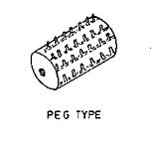
Figure 1: Peg Type
2.2.3.2 Rasp bar type cylinder
in this type of cylinder, there are slotted plate, which are fitted over to the cylinder rings in such a way that the direction of slot of one plate is opposite to another plate. This type of cylinder is commonly used in threshers. It gives better quality of grain and it can be used for a wide variety of crops.
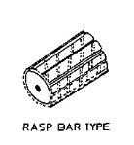
Figure 2: Raspbar Type
2.2.3.3 Wire loop type cylinder
in this type of threshing drum, there is hallow cylinder over which a number of wooden or mild steel plate are fitted. On these plates, number of wire loops is fixed for threshing purpose. Holding the bundle against the loops of revolving cylinder does threshing of paddy crop.
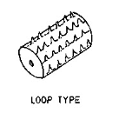
Figure 3: Loop Type

2.2.3.4 Cutter blade/syndicator type cylinder
this is essentially on adoption of chaff cutter for threshing. The crop is fed as is done in case of chaff cutters. After passing through a set of rollers, crop is cut into pieces. Varying the set of gears can vary the size. Threshing is done mainly due to cutting helped by rubbing and impact. The main advantage of syndicator thresher is that it can handle crop with higher moisture content. However, chopping knives need to be sharpened every 3-5 hours of operation. The machine is more prone to accident due to positive feed rollers.
2.2.3.5 Hammer mill type cylinder
it uses beaters to do the required job of threshing. The shape of this type of cylinder is different from the above discussed cylinder. The beaters are made of flat iron pieces and are more fixed radically on the rotor shaft. Generally, feeding chutes are used with hammer mill type threshing cylinder. The cut crop is fed perpendicular to the direction of motion of rotating beaters. This type of thresher requires power as compared to spike tooth type.
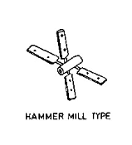
Figure 4: Hammer Mill Type
2.2.4 Concaves
Cylinders and concaves together make the threshing unit. It separates the grain from the crop and removes grain from the straw. Concave is provided in the thresher to hold the fed crop inside the threshing chamber and allow only grain and small amount and chaff to pass through it. The threshing takes place only in this place it is a curved unit made of iron steel fitted near the threshing cylinder. There is clearance between cylinder and concave depending on size of grain for multi crop threshers. There are different types of concaves:
- Screen type concave
- Perforated concave

2.2.4.1 Screen type concave
It is made of mild steel rod. It is semicircular in shape and sometimes made with wire also. The screen allows the materials after threshing to pass through its perforation.
2.2.4.2 Perforated concave
In this, perforations are made in a mild steel sheet. The concave is closed from both the end by iron sheet. The size of perforation is made as per the size of grain of a crop.
Cylinder speed is also considered. The drum of the thresher should be rotated at proper speed for better threshing. Cylinder speed is checked using tachometer.

2.3 Performance Evaluation
A good productive measure attained by result is regarded to as performance evaluation. Grain traditional threshing method yields a low performance evaluation. Input, threshing and cleaning efficiency are the performance evaluation considered.
Performance evaluation is considered after the feed rate, threshing efficiency, breakage efficiency and cleaning efficiency of grain under different drum speed and moisture content have been determined (Fulani et al, 2013).
Input efficiency is firstly determined by the shape of hopper because grains feed differ for selected type of hopper (Farm machinery and equipments).
Threshing efficiency requires quite some specifications depending on grain that want to be threshed (Farm machinery and equipment). Cylinder type, moisture content, rotor speed, feed rate, output rate, etc. are amongst the measures that produces threshing efficiency.
Cylinder type affect grains to be threshed if the proper type is not used (Farm machinery and equipment). Millet threshers have produced more threshing efficiency using the peg type cylinder (Fulani etal, 2013) Bean threshers have produced more using the hammer mill type cylinder (Wamalwa et al, 2022) If the selected cylinder type is not suitable for the grain, there is possibility of a low threshing efficiency and high breakage efficiency.
Grains are better threshed at suitable seed moisture content (Asanteet al, 2017). Threshing at suitable moisture content gives a good threshing efficiency and less breakage efficiency.
Feed rate or input efficiency also determines the threshing efficiency in a sense that that the threshing chamber needs to be choked so as not to give allowance for grain damage (Charturvedi and Rathore, 2018).
All the above measures were used to test the performance evaluation of a common bean thresher and the result yielded a very good outcome (Wamalwa et al, 2022). A cowpea thresher performance evaluation was also measured by effect of seed moisture content (Fulani et al, 2013).

2.4 Analysis of Literature Review
This study entails the need for a proper input unit of the thresher and also gives a proper selection format for bean. Previous bean threshers have cylinder rather unsuitable type of threshing cylinder type. The importance of cleaning unit is also advised in this study.
In summary, this study shows that the throughput threshing, breaking and cleaning efficiency will produce a more positive result compared to previous work cause material and design where properly evaluated and a suitable one was selected.

CHAPTER THREE
3.0 DESIGN THEORY AND ANALYSIS
Based on the objective of the study, bean threshing machine is to be designed and constructed and from the principle of design, there is need for engineering specifications, development of alternative, concept, detail design and selection of materials. This chapter comprise of the design theory, design calculation and selection of materials.
From engineering specifications entail the throughput i.e. the weight of the beans that will be inputted into the machine, the required volume of chamber, the required speed of the fan. Furthermore, in conceptual design, the alternative concept for each of the units are presented and evaluated. Thereafter, each of the components part is designed by calculating the forces on them in action. The second sections contain the method of manufacturing each component and the assembly of the machine. Also the third section entails the method for evaluating the machine.
3.1 Design Theory
3.1.1 Design Theory for bean thresher
The design of bean thresher is based on the property of beans which easily breaks. The first factor considered is the speed transmitted to the threshing shaft when the speed is over the grain to be threshed. Another factor considered in order to achieve minimum breakage efficiency is the type of beaters or threshing cylinder such as spike tooth type cylinder, rasp bar type cylinder, wire loop type cylinder and hammer mill type cylinder.
3.1.1.1 Spike tooth type
in this type of threshing drum, there is a hollow cylinder made out of mild steel. Over to its entire periphery, a number of spikes of square/round bars on flat iron pieces are welded or bolted. Nowadays, in most of the threshers, round pegs with adjustable length are used. These spikes are staggered on the periphery of the drum for uniform threshing. The crop is along with the direction of motion of the rotating drum. The spike tooth cylinder with spikes of flat front and streamlined back has lower energy consumption.

Figure 5: Peg Type
3.1.1.2 rasp bar type cylinder
in this type of cylinder, there are slotted plate, which are fitted over to the cylinder rings in such a way that the direction of slot of one plate is opposite to another plate. This type of cylinder is commonly used in threshers. It gives better quality of grain and it can be used for a wide variety of crops.
Figure 6: Rasp Bar Type
3.1.1.3 Wire loop type cylinder
In this type of threshing drum, there is hallow cylinder over which a number of wooden or mild steel plate are fitted. On these plates, number of wire loops is fixed for threshing purpose. Holding the bundle against the loops of revolving cylinder does threshing of paddy crop.
Figure 7: Loop Type
3.3.4 Hammer mill type cylinder
It uses beaters to do the required job of threshing. The shape of this type of cylinder is different from the above discussed cylinder. The beaters are made of flat rubber pieces and are more fixed radically on the rotor shaft. Generally, feeding chutes are used with hammer mill type threshing cylinder. The flat rubber hammer was selected to reduce breakage of the threshed grains.
Moreover, when the threshed beans are beaten repeatedly when there is no more un-threshed beans inputted it does not break the grain. This satisfies our objectives. This type of thresher requires power as compared to spike tooth type.
Figure 8: Hammer Mill Type
3.2 Design Analysis
3.2.1 Conceptual design
The bean thresher is segmented into different unit which comprise of the hopper, threshing unit, cleaning unit and the output unit. Each unit has their different function.
3.2.1.1 the hopper
The feeding unit can be designed and fabricated in different shape considering the working capacity of the machine. The hopper should be constructed to increase machine efficiency and avoid hazard during operation. There are types of hoppers specially designed and shaped in thresher which constitute of the conical, frustum, trapezoidal and prism. Thereafter, the style to which flow of the feeding un-threshed crop, it is to flow tangentially, axially or in a conveyed form.
Prism shape of hopper was selected in our work for easy feeding into the threshing chamber. Meanwhile, tangential flow style was chosen in order to minimize the unnecessary flying out of the grain.
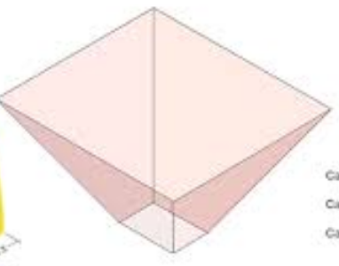
Figure 9: Hopper
3.2.1.2 threshing chamber
This is a unit in which threshing takes place. This unit consist of threshing drum, the lower concave screens and the side plate. It was welded on the main frame.
3.2.1.3 The screening unit
The screen is also subdivided; there is screen made of straight wires and the one made from mild steal which are drilled for grains to pass through them. The screen is a metal sheet fabricated with drilled holes marked at regular intervals which is concave below the threshing chamber. The holes are dimensioned in such a way that grains pass through. The screen was rolled to a concave shape with flange at the two sides and bolted to the frame. The drilled holes metal sheet was selected to satisfy the concept for this design.
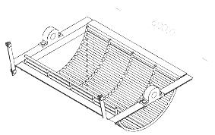
Figure 10: Concave Screen
3.2.1.4 The cleaning unit
The fan is provided with a covering for directing the air to blow off the chaff out of the grains for good cleaning efficiency, hereby separating the grain from the stalk and chaff. In this section, there are two types of cleaning method; the suctioning fan of and the blowing fan. Blowing fan was chosen for the design of this bean thresher.
Based on the review of other thresher like soybean, millet and cowpea threshers the design constructed shakers for cleaning of the grains, instead blowing fan was constructed with an incline plane which can be adjusted to any specific angle of inclination when necessary, the angles ranges from 45˚, 55˚ and 65˚depending on the speed. Low blowing speed the incline plane should be adjusted to 45˚, moderate blowing speed at 55˚ while at high speed 65˚. When the speed of the prime mover is higher and adjustment remains at lower angle of inclination, both the chaff and the grains would be blown out.
3.3 Material Selection
3.3.1 Detail design
The design of bean thresher is based on manual powered mechanical thresher; the expected maximum throughput is 100kg/hr. An attachment is provided on the side for a mount of 6HP petrol engine for powering the thresher. The main designs of the machine are the hopper, drum shaft, the main frame and the blower.
The hopper is a prism shaped at the top projected into the threshing chamber.
Threshing chamber comprises of the shaft carrying straight and rubber hammer beaters which are meant to repeatedly hit the stalk unit. The seeds are removed from the stalk. Below the threshing drum is the screening plate which is a concave perforated over its surface area so that only the needed seeds and chaff can pass through while the stalk is retained on the chamber . The cleaning unit which comprises of a blower directly connected to the end of the shaft using belt and pulley to blow off the chaff and the threshed grains fall through the opening for collection.
- The hopper
The volume of the hopper is chosen such that it can contain the desired throughput of 10kg.
Vh=L×B×H……………………………………………………… (1)
Based on the selected throughput where Vh is obtained from the relation:
Vh=w/pg
The breadth and height are chosen arbitrically as 160mm and 360mm respectively the length of the hopper is determined in (i)
L= w/pgbh………………………………………………….…….(2)
Density of beans is chosen approximately as density of fiber= 778kg/m3. The materials chosen for the hopper is mild steel due to its thickness and availability. Tensile strength of the mild steel is 42mPa.
Thickness of hopper sheet: the thickness obtained by considering it as an open vessel subjected to internal pressure due to the height of the input materials. Considering the effect of longitudinal section of the hopper.
=intensity of pressure × projected are
=P×L×H (khurmi and gupta, 2006)
The total resistance force=2 σ ×t×L
P×L×H=2σ×t×L…………………………………………….(4)
t=ph/2σ………………………………………………………(5)
The screen is also subdivided ; there is screen made of straight wires and the one made from mild steel which are drilled for grains to pass through them, But
but P=w=w/(l+b)h
t= w/2(l+b)σ………………………………………………………………(6)
Design calculation for selection of hopper material
S/n Initial Data Calculations Results
1.w=10kg  P= 778kg/m³  B= 160mm  W= 10kg  l= 360mm  b= 160  = 42mPa | Length of hopper  t= w/pgbh  t=10/778×0.16×0.36  t=0.61m  t=w/2(l+b)σ | t=0.61m  t= 0.0023m
(ii) Design and selection of materials for threshing chamber
Considering the throughput of 10kg, based on the effect of the rotation in the chamber
Vn= VcWwR²/pg²
WwR²/pg²=πR²t
= WwR²/pg²……………………………………………………………(7)
The thickness of the chamber is obtained
from = pt/2σ same as hopper.
WwR²/gAs= WwR²/4gπσ...................…………………………………(8)
Design calculation for selection of material for threshing chamber.

Initial data Calculations Results
W=10kg tWwR²/4gπσ. t= 0.4m
R= 160mm w= 2πN/60
σ=42Mpa =2×3.142×2000/60
W=209.5
t= 10×209.5×10^3/4×9.81×3.143×42
= 404.5mm

(iii) Design and selection of materials for the screen
The screen is perforated with a hole size slightly greater than the maximum grains size of beans. Based on the experiment, the maximum size of beans available is 3.4 and 4 is chosen as hole size.
The thickness of the screen is determined by considering the force exerted by the beans. This force is equal to the centrifugal force due to the action of the threshing drum on the material.
F=WwR^3/g........,.....,.......….....…...…...…....................................(9)
From bending equation
σ=m/z (Khurmi and Gupta, 2006)
but z=hb^2/6 and σ=6m/hb^2
M=FR=WwR^3/g
σ=WwR^3/ghb^2.
Design and selection of pulley and belt
Three pulley were used on the thresher; a pulley was used on the threshing shaft, the blower and the prime mover
Determination of the cylinder shaft driven pulley size.
N₁D₁=N₂D₂
N₁=2OOOrpm
N₂= 1200rpm
D₁= prime mover pulley size 104mm
Determination of V-belt length.
The length(L) of V-belt used in the design of the thresher were obtained as (khurmi and gupta, 2007)
L=
The equation was used for the determination of the length of the open belt used in the thresher. Length of the open belt between cylinder and reciprocating unit pulleys.
L₂=
D₄= diameter of small cylinder pulley= 250mm
D₅= diameter of fan pulley= 150mm
C₂= distance between the center of cylinder and fan pulleys= 880mm
Substituting:
L₃= 2049.30mm
Determination of angle of lap of belt
- Length of belt
For the purpose of determining the angle of lap of belt on pulleys (khurmi and gupta, 2007). Equation A and B were used for open and cross belts respectively.
Ө= (180-2)
= sin
= sin
Where:
D= diameter of larger pulley in mm
d= diameter of smaller pulley in mm
c= distance between the center of two pulley in mm
ө= angle of contact at the drums pulley = 3.67rad
Determination of belt tension.
For the determination of tensions in belt, the equations below are given by Khurmi and Gupta (2007) were solved simultaneously as:
P= (T₁-T₂)V
I₁= ecosec
T₁ and T₂ are the tension in newton’s on the tension and slack sides of the beltrespectively.
N= speed of prime mover
d= diameter of pulley in m
ө= angle of lap (in radian) as given by 3.11
µ= coefficient of friction between belt and pulley by Khurmi and Gupta (2007) given on table 3.1 and ß= 20
Determination of tension in belts tension in belt is gotten by solving equations simultaneously where; µ= 0.32, v= 10.84m/s, ß= 20° and p= 1800w
Where N = number of revolution per minute.
Pulley description of co-efficient of friction
1 cast iron cylinder drum 0.27
Pulley driven by prime mover
Cylinder pulley 0.27
Driving the blower
Source: Khurmi and Gupta (2007)
Determination of tensions in belts
Tension in belt is gotten by solving equation 8 and 9 simultaneously where,
U= 0.32, 9 = 2,66rad, v=0.84ms,
B= 2Q, and P= 1800w
Therefore Tf is the tension in the tight and slack sides of the belt linking cylinder shaft. The belt driving the fan, on the developed thresher was inclinded at 63⁰ to the horizontal. This the vertical component of the sume of the tensions of the blower belts is 169.9IN. and the horizontal component is 16.58N. Simultaneously where;
U = 0.27
0 = 3.08rads
V=1.39m5-¹
B= 20; P = 554.4W
P=554.4ww
Therefore TR1 = 437.29N and TR2 = 38.46N
Where TR1 and TR2 are the tensions in the tight and slack of the belt linking cylinder shaft to the blower shaft respectively. Also, tension in belt from prime mover is gotten from solving 8 and 9 equation simultaneously.
Where;
µ = 0.27, Ɵ = 3.79rads, V = 10.84m5¹, ᵝ=20⁰ and P= 2357.14W
therefore Tm² = 228.28 Tm² = H.48N
Where TM1 and TM2 are the tensions in the light and slack sides of the belt linking the prime mover to the cylinder shaft respectively. 35.65 Design for Key
Keys are used to maintain relative motion b/w the shaft and the connected members through which torque is being transmitted. (Khurmi & Gupta, 2008).

Rectangular Sunk Key
A rectangular sunk key is considered for this machine. The usual proportions of the key are width of Key, W = 1 and thickness of key, t = 2wd where d = diameter of the shaft or diameter of the hole in the hub. Let
T= Torque transmitted by the shaft
F=Tangential for a acting at the circumference of the shaft.
d= diameter of shaft
I= length of key
W= width “”
t= Thickness of key and I and 8c =
shear and crushing stresses for the material of key (Khurmi & Gupta, 2008) considering shearing of the key, the tangential shearing force acting at the circumference of the shaft, may be expressed as follows;
F= Area resisting shearing x shear stress
= 1 χ w χ T
Torque transmitted by the shaft
T = Fχ ^{d}/₂ = 1χ wχTχ^{d}/₂
Considering crushing force acting at the circumference of the shaft is given by
F= 1χ ⁺/₂ χ Tc
Torque transmitted by the shaft
T = F χ d1χ t χ Fc χ d…………. …………………………………………...(10)
2 2 2
Equating equation 30 & 31 we have
W = tc ………………………………………………………………………(11)
T 2
In order to find the length of the key to transmit full power of the shaft, the shearing strength of the key is equal to the torsional shear strength of the shaft.
i.e T = 1χ w χ t χ ^{d}/₂ = ^{π}/₁₆ χ t χ d³
take T = shear stress for the shaft.
1 = 1.571.dxt …………… ………………………………………………….(12)
t
when the key material is same as that of the shaft, then
1 = 1.571d……………………………………………………………………(13)
3.4.7 Design for bearing selection
A bearing is a machine element which support another moving machine element (known as journal) H permet a relative motion between the contact surfaces of the members while carrying the load (khurmi and Gupta, 2005).
Roller bearing application involves the proper selections, mounting, lubrication, and possibly shielding in order that the bearing function satisfactory under specific operation this selection is made from the manufacturer catalogue.

- Standard Dimension and Designations of Ball Bearing.
Dimensions that are function of the bearing bore and series of being, these are bore, outler diameter and width and are in millimeters. There no standard for size and number of steel balls, (Khurmi & Gupta, 2008). The bearing are designed by a number. In general, the number consists of at least three digits. The last three digits gives the series and the bore of the bearing (Khurmi & Gupta, 2003).
- Selection of Radial Ball Bearings
In order to select a most suitable ball bearing, first of all, the basic dynamic radial load is calculated. It is thin multiplied by the service factor (Ks) to get the design basic dynamic radial load capacity, (Khurmi & Gupta, 2008).
C = W (L)
106
Where,
W= Dynamic equivalent radial load =
XV W_{R}+ Y.W_{A}
V= A rotating factor
= 1, for all types of bearing when the inner roll is rotating
L = Rating life K=3, for all ball bearing W_{R}= Constant radial load W_{A}= constant axial or thrust load.
X & Y are factors depending on ratio of W_{A} to W_{R}

Design for Bearing
Data Design Calculation Result
d= 35mm A single row deep groove ball
WR= 1167N bearing of bearing No. 207 was outside diameter = 72mm width = 17mm
WA= 455N Selected (Khurmi & Gupta, 2008)

Bearing on Threshing Shaft
d= 35mm a single row deep groove ball bearing of No 207 was selected diameter Bore = 35mmoutside Diameter
=72mm
W_{A} = Khurmi & Gupta, 2008) Width= 17mm
Check on the Bearing Selected
C₀ = 13.7KN W_{A} = 65 W_{A}
V= 1 C₀ 13.7x10³ Co
L_{H} = 8000hrs = 4.74x 10⁻³ = 4.74 x 10⁻³
N= 740r pm W_{A}= 44.97 W_{A} = 0.029
K = 3 W_{R}= 1574.07 = 0.301 W_{R}

Since W_{A} < available value of е
W_{R}
( i.e -<S) the value of X and y X=1
are 1 W_{R} and O respectively x =O
The life of bearing in revolution is;
L= 6Ojv x L_{H} = 60 X 740X8000 L = 355.28
The basic dynamic equivalent radial x 10⁶ rev load is;
= 216 (355.2x10⁶) (=1529.7IV)
106
Since 1529.7N <20KN which
Is the dynamics capacity of the bearing chosen, the bearing is satisfied.

Design for Shaft
The shaft is a rotating member, usually of circular cross section, used to transmit power or motion (Bulgnas and Nisbett, 2008).
The shaft used for the machine is designed based on the following considerations;
- Strength
- Critical speed
- Rigidity and stiffness
- Designing of Shaft on the Basis of Strength
In designing shaft based on strength, the following may be considered.
- Shafts subjected to twisting moment or torque only.
- Shaft subjected to bending only
- Shaft subjected to combing twisting and bending moments, and
- Shaft subjected to axial loads in addition to combined torsional and bending loads.
When a shaft is subjected to combined twisting and bending moments, then the shaft must be design on the basis of the two moments simultaneously. Various theories have been suggested to account for the elastic failure of the materials when they are subjected to various types of combined stresses. The following two theories are important in design;
- Maximum shear stresses theory or gusset’s theory. It is used for duetile mateials such as, mild steel.
- Maximum normal stress theory or rankin’s theory. It is used for brittle materials such as cast iron.
Lev 2:
i= shear stress induced due to twisting moment, and Jb
= Bending stress (tensile or compressive) induced due to bending moment.
According to maximum shear stress theory.
The maximum shear stress in the shaft may be expressed as
Jmax = $1\sqrt{{\left(Jb\right)}^{2}+{4ζ}^{2}}$……………………………………………………..(14)
Substituting
32M and 16T for Jb and J in
Πd³ Πd³

In equation (15) above we have
Jmax = $\frac{1}{2}\frac{\sqrt{\left(32\right)2+ \left(16T\right)2}}{Πd3 Πd3}$……………………………………………………..(15)

Max = 1Πd³$\frac{\sqrt{M2+ \left(T\right)2 or }}{Πd3 Πd3}$Π x Jmax X d 3 = $\frac{\sqrt{M2+ \left(T\right)2 }}{}$
16
The expression $\sqrt{M2+\left(T\right)2 }$ is known as equivalent twisting moment may b defined as the twisting moment may be defined as the twisting moment, which when acting alone, produces the same shear stress (T) as the actual twisting moment. By limiting the maximum shear stress ( Tmax) equal to the allowable shear stress (T) for the material, the equation (11) may be written as
Te = $\sqrt{M2+ \left(T\right)2 }$ = Π x τ x d²
From this expression, diameter of the shaft (d) may be evaluated.
Now according to maximum normal stress theory, the maximum stress in the shaft.
Qb (Max) = ^{½} qb^{4½}$\frac{\sqrt{\left(qb\right)2+τ 2 }}{}$
Qb (Max) = ^{½} x (32m)² + 4 (16T)²
Πd³ Πd³
Qb (Max) = 32 (M + $\sqrt{M2+ \left(T\right)2 }$
2
Or Π x qb (max) xd³ = ^{½} + (M + $\sqrt{M2+ \left(T\right)2 }$

The expression ^{½}(M + $\sqrt{M2+ \left(T\right)2 }$
Is known a equivalent bending moment and is denoted by me. The equivalent binding moment may be defined as the moment which when acting alone produces the same tensile or compressive 8_{b} as the actual binding moment. By limiting the maximum normal stress Qb (Max) equal to the allowable binding stress, then equation may be written Me =
^{½}(M + $\sqrt{M2+ \left(T\right)2 }$ = Π x Qb x d³
32
But taken the combined shock and fatigue factor for bending and torsion.
(i.e K_{m} and k_{t} respectively) into account.
Te = $\sqrt{Km x M)2+(Kt x T)2 }$ ………………………………………………(16)
and
Me = ¹/₂ ( Km x M + $\sqrt{Km x M)2+(Kt x T)2 } …$…………………………..(17)
From this expression, the diameter of the shaft (d) may be evaluated. The maximum permissible working stresses in tension or compression for shafts with allowance for keyway was taken as 84 Mpa and maximum permissible shear stress for shafts with allowance for keyway was taken as 42 Mpa.
Km and Kt are 1.5 and 1.0 respectively for gradually applied or steady load (Khurmi & Gupta, 2008).

- Critical speed
Considering the shaft under critical speed,, the Rayleigh-Ritz equation for critical speed can be simplified as follows:
Ncr = Critical speed of the shaft
K = 48 Elfor simply supported shaft, (N) …………………………………….(18)
L³
W = Weight of rotating part fixed on a shaft (N)
The recommended working speed, may be taken as;
n = 75%Ncr
or ncr = 1.3n for supercritical speeds …………………………………………(19)
- Rigidity and stiffness
The torsional deflection may be obtained by using the torsional equation.
T = G.Ɵ
J L
Or Ɵ = T.L
J.L
Where,;
Ɵ = Torsional deflection or angle of twist (rads)
T = Twisting moment or toque on the shaft
J = Polar moment of inertia of the cross
- Sectional area about the axis of
Rotation = Π x d⁴
32
G = Modulus of rigidity for the shaft mat.
L= Length of the shaft V
Table 5; Design for Shaft
Threshing Shaft
LA =
LB= 1235.3mm
XA= 750mm
XB= 450mm
WUB= 295IV
WUB = 151V
(Wsp)T= 20IV
Fig. 6: Analysis of load on shelling shaft (All dimension in mm)
The tension in the belt b/t the prime mover and the threshing shaft was inclined at an angle 90 to the horizontal and that b/t the shelling shaft and blower was inclined at an angle = ᵅ.
1832

750
750
Cos Ɵ = 750
1832

Ɵ = C05-¹ (750) = 65.83⁰ Ɵ = 66⁰
1832

123.3

450 ᵅ = N69⁰
Cos x = 450

ᵅ= Cos -¹(550)
1232.3 = 68.64⁰Ɵ = 66⁰
y = Wub + WD+ (Wsp)T
460
y = 295+15+20T
460
y = 0.72N/mm
Vertical and Horizontal Load at A&B
TB = 1260N FAV = Tb Sin Ɵ + Wp FAV = 1175N
TB = 345Jv
Wp = 20N FAV= 1260 Sin 66⁰ + 20
Ɵ = 66⁰ = 1171.1N
Y=69⁰ FAH = Tb Cos Ɵ FAH= 515N
FAH = 1260 Cos 66⁰ = 512.5N
FBV= TB Sin ᵅ + Wp
= 345 Sin 69⁰ + 20 = 342.1N FAH = 345N
FBH = TBCOS ᵅ = 345 Cos 69⁰ FBH= 125N
= 123.6N
Vertical and Horizontal Reaction at Bearing C&F
FAV = 1175N
FBV = 345N
Y= 0.71N/mm
F’B = 210N
FAH=515N
FBH = 125N
Fig.7: Vertical load diagram of shelling shaft
Vertical load diagram
Ʃfv= 0
1175-345-Rcv+Rfv-210+(0.7$×$460) = 0
Rev – RFC + 951.2 = ON
Taking moment about point C, We
have;
(1175x100) – (345 x 80) – (331.2 x 325)
- (Km x 650) + (210 x750) = 0
139760-650RFV= 0
RFV 139760 = 215.02N RFV = 216N
650 Rcv = 951.2 + RFV

Rcv = 951.2 + 215 = 1166.2N Rcv = 1167.ON

Performance and Evaluation
The beans stalk weight 250kg prepared for the performance and test. The total beans weight was used for the experiment hence fed into the hopper with the machine speed of47_71rpm for easy threshing of beans.
i. Through Put Capacity
The through put capacity ranged from78.3kg/he to 97kg/hr at a threshing speed of 47 to 71rpm. The through put capacity yielded the best result at 71rpm.
ii. Threshing Efficiency
The threshing efficiency ranged from 78.4% to 98.6% at the threshing speed of 47 to 71rpm. The threshed grain was weighed on a scale, it was 242kg and the chaff was also weighed on a scale 8kg.
iii. Breakage Efficiency
The percentage breakage was at least 3% at 71rpm of the machine speed when tested with beans at 8-12% seed moisture content.
CHAPTER FOUR
4.0 MANUFACTURING PROCESSES
The construction of a beans thresher is made to operate using various components parts which consist of a hopper, threshing chamber, sieve, beaters, threshing drum shaft, belt, pulleys, bearing, blower and the main frame.
Measurements, marking out, dimension of the component part and cutting to the required size, welding (arc), drilling operation, threading operation, drilling operation, spraying (Painting) operation, brazing operation and bending operation.
The selection will surely influence weight, strength, appearance after construction and the overall cost of production.
4.1 Main Component Manufacture
- Hopper
- Threshing chamber
- Blower
- Bolts and nut
- V-belt
- Threshing hammer
- Concave screen
- Pulley, bearing and the housing
- Frame
4.1.1 Hopper
This is the introductory section of the beans pods into the threshing chamber. The hopper is designed and fabricated in a prison shape made from a mild steel plate of 2mm thickness. The top area size of the hopper is designed to 390mm, base at 300mm at an angle of 45°, this angle is suitable for easy and steady flow and the maximum feed during operation.
4.1.2 Threshing chamber.
It is the part where the beans grains are detached from the stalks and chaff. Mild steel sheet was chosen and fabricated as housing. The threshing chamber consist of a rotary drum for threshing which perform the threshing action. The beaters are flexible flat rubber constructed element in space at equal interval and at regular length from each other. The space between them is 50mm, shaft length 380mm and the diameter of the hammer beater 20mm. The beaters were designed with (6×4) parallel bars welded at different angle and spacing along the drum shaft based on an old paddy threshers.
4.1.3 The blower
The cleaning unit has an essential part for separation of chaff from the grains. The blowers consist of 60mm diameter mild steel shaft which rest on a ball bearing at the two ends on the rectangular stand. The three blade (steel plate) which are arranged and attached on the shaft periphery alternately at an angle 120° along the shaft (rotor). When the fan rotate there would be a pressure directed to the incline plane which blow off the chaff and stalk as the grains is collected at the output.
4.1.4 Bolts and nuts
A bolt is a form of threaded fastener with an external male thread requiring a matching pre-formed female thread such as a nut. Bolts are very closely related to screws. The bolt consists of a head and a cylindrical body with screw threads along a portion of its length. The nut is the female member of the pair, having internal threads to match those of the bolt. Washers are often used to prevent loosening and crushing.
4.1.5 V-belt
A v-belt is a loop of flexible material used to link two or more rotating shafts mechanically, most often parallel. Belts may be used as a source of motion, to transmit power efficiently or to track relative movement. Belts are looped over pulleys and may have a twist between the pulleys, and the shafts need not be parallel.
In a two pulley system, the v-belt can either drive the pulleys normally in one direction (the same if on parallel shafts), or the belt may be crossed, so that the direction of the driven shaft is reversed (the opposite direction to the driver if on parallel shafts). The v-belt drive can also be used to change the speed of rotation, either up or down, by using different sized pulleys.
As a source of motion, a conveyor belt is one application where the belt is adapted to carry a load continuously between two points.
    - Threshing hammer
this was constructed using rubber hammer mounted unto a mild steel rotating star wheel. The threshing hammer was mounted on the shaft.
    - The concave screen
this is made of 4mm thick mild steel sheet with 8mm holes. it was bent into a half circle so as to fit into the threshing chamber.
4.1.8 Pulley, bearing and the housing
the pulleys were made of cast iron which is machined on the lathe to give the required diameter. The pulley mounted on the shaft is a one way groove which has a diameter of 150mm and the groove length of 10mm. the bearing called UCP bearing and housing with bolt and nut provision for fastening. The bearing used is a ball bearing.

    - Frame
the supporting frame carries the weight of the entire component mentioned above. It was constructed with a 40x40mm angle iron cut to required shape and permanently joined together using the welding.

4.2 Tools and Equipment
    - Tools
Marking out or layout means the process of transferring a design or pattern to a work piece, as the first step in the manufacturing process. It is performed in many industries or hobbies although in the repetition industries the machine's initial setup is designed to remove the need to mark out every individual piece.
- Scriber
A scriber is a hand tool used in metal work to mark lines on work pieces, prior to machining. The process of using a scriber is called scribing and is just part of the process of marking out. It is used instead of pencils or ink lines, because the latter are hard to see, easily erased, and imprecise due to their wide mark; scribe lines are thin and semi-permanent. On non-coated work pieces marking blue is commonly used to increase the contrast of the mark lines.

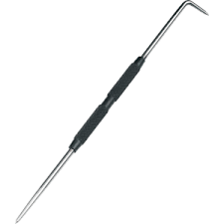

Figure 11: Scriber
- Hack saw
A hacksaw is a fine-toothed saw originally, specifically and mainly made for cutting metals. It has a handle, usually with a pistol grip, with pins for attaching a narrow disposable blade.
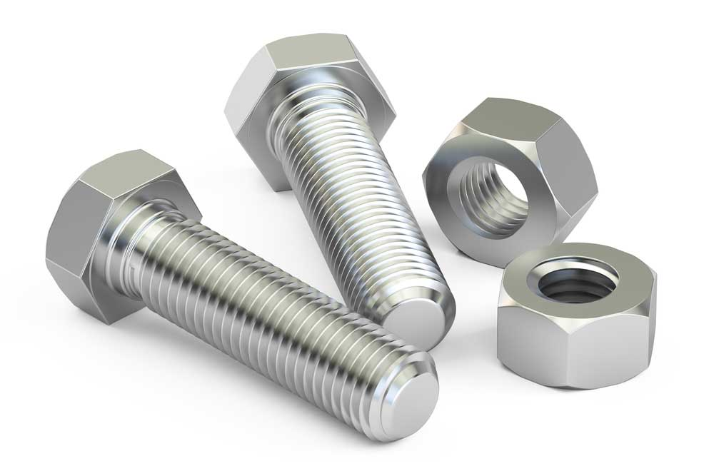
Most hacksaws are hand saws with a C-shaped walking frame that holds a blade under tension. Such hacksaws have a handle, usually a pistol grip, with pins for attaching a narrow disposable blade. The frames may also be adjustable to accommodate blades of different sizes. A screw or other mechanism is used to put the thin blade under tension.
On hacksaws, as with most frame saws, the blade can be mounted with the teeth facing toward or away from the handle, resulting in cutting action on either the push or pull stroke. In normal use, cutting vertically downwards with work held in a bench vise, hacksaw blades are set to be facing forwards.
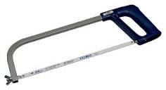

Figure 12: Hack Saw
- Hammer
A hammer is a tool most often a hand tool consisting of weighted head fixed to a long handle that is swung to deliver an impact to a small area of an object.
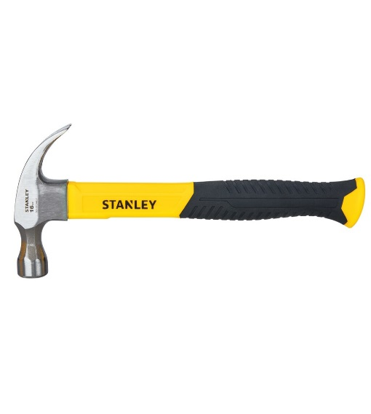
Figure 13: Hammer
- Spanner
A wrench or spanner is a tool used to provide grip and mechanical advantage in applying torque to turn objects usually rotary fasteners, such as nuts and bolts or keep them from turning. It is a tool with shaped opening or jaws for gripping and turning a nut or bolt.
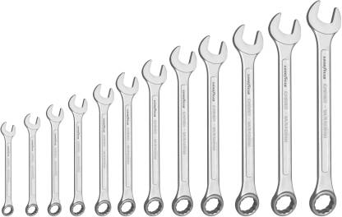

Figure 14: Spanner
- Screw driver
A Screw driver is a tool with flattened or cross-shaped tip that fits into the head of a screw to turn it.
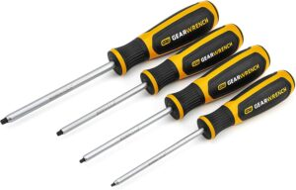

Figure 15: Screw Driver

- Filing machine
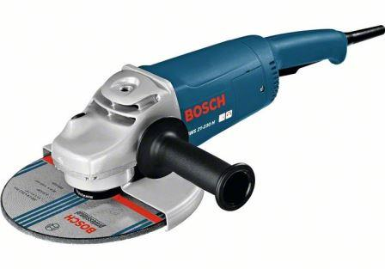
A power-machine for filing metals, resembling in general plan a scroll-saw in which the vertical reciprocating saw is replaced by a file. Is a machine that is used to remove fine amounts of materials from a work pieces. It is common in woodworking, metal working, and other similar tasks.

Figure 16: Filing Machine
- Drilling machine
A drilling machine is machine or tool primarily used for making round holes or driving fasteners. It is fitted with either drills or a driver depending upon the application secured by chuck.
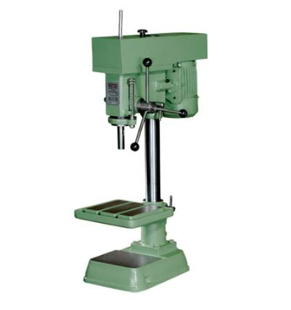
Figure 17: Drilling Machine
- Cutting machine
Metal cutting machines are machine tools used to fabricate parts by the removal of material, typically metal. A cutting tool or cutter is typically a hardened metal tool that is used to cut, shape, and remove material from a work piece by means of machining tools as well as abrasive tools by way of shear deformation.
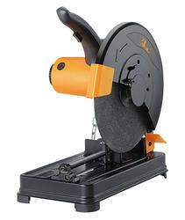
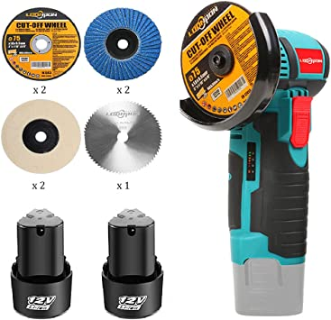

Figure 18: Cutting Machine
- Spraying (painting) machine
Spraying Machine is pneumatic equipment uses to apply a surface coasting (Paint) to an object by the means of atomized liquid are propelled through the, usually by compressed air.
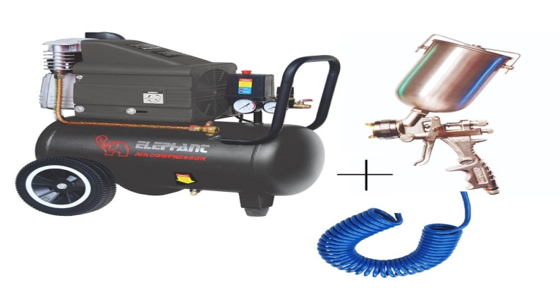

Figure 19: Spraying Machine
(j) Arc welding machine
These processes use a welding power supply to create and maintain an electric arc between an electrode and the base material to melt metals at the welding point. They can use either direct current (DC) or alternating current (AC), and consumable or non-consumable electrodes. The welding region is sometimes protected by some type of inert or semi-inert gas, known as a shielding gas, and filler material is sometimes used as well.
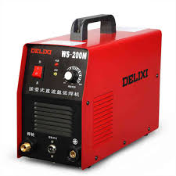
Figure 20: Arc Welding Machine
4.2.2 Equipment
The following equipment was used for the study
- HP Laptop Computer with number Version 1909 Windows 10 Pro Edition was used for typing and printing with Microsoft word 2016 and AutoCAD Software’s.

4.3 Operation Sequence
The Operation Sequences for the manufacturing of a Beans threshing machine are as follows;
Operation Sequence
S/N | Operation |  |  |  |  |  |  | Procedure | Tools & Equipment
1 |  | Measuring and marking out of the work piece |  | Materials such as angle bars and plates needed at all points were measured and marked out clearly. |  |  |  |  | Work Bench, measuring tape, steel rule and scriber.
2 |  | Cutting |  |  | The materials were held firmly on bench vice and cut effectively along the marked points. |  |  |  | Hack saw and bench vice.
3 |  |  | Welding of Frame |  |  | Height and width of the sized angle bar were joined at right angle to one another. |  |  | Electric arc welding machine and electrode.
4  5 |  |  | Drilling  Threading |  |  |  | Used for making round holes or driving fasteners were necessary  Process of creating a screw thread There are many methods of generating threads, including subtractive methods, deformation or transformative methods additive methods or combinations thereof. |  | Drilling Machine and cooling fluid or water.  Threading Machine
6 |  |  | Brazing |  |  |  |  | During the brazing process, the filler metal flows into the gap between close-fitting parts by capillary action. The filler metal is brought slightly above its melting (liquids) temperature while protected by a suitable atmosphere, usually a flux. | Brazing Machine with cooling liquid or fluid

4.4 Assembly of Beans Threshing Machine
The Construction of the Beans threshing machine was completed by joining the entire previous machine component together. The frame assembly process starts with the cutting of angle iron using Saw Blade and cutting machine to a required measurement. Arc Welding Machine of 50A with 15 gauge electrodes was used to weld the rectangular shape frame of the machine. The components are properly aligned such as the petrol generator and blower, bolts and nuts are used to help them down by the use of spanners or wrench to avoid vibration of the machine. V-belt is used to transfer energy from the petrol generator to the threshing chamber and blower.
4.4.1 Types of assembly
- Welding (Permanent Joint)
- Bolting (Temporary Joint)
- Finishing

4.4.2 Welding
This permanent type of joint will be used in the areas that will not require any Servicing. These include; the frame and the body of the machine etc.
4.4.3 Bolting
The temporary joint is used in the areas where operational life of the machine may require servicing or maintenance of any forms such as the petrol generator, collector, etc.
4.4.4 Finishing
In order to give a fair industrial finishing applied on the construction of the machine are surface cleaning using an iron brush, sand paper, grading or filling machine and finally painted to protect the machine parts from corrosive reaction with the environment.

4.5 Bill of Engineering Measurement and Evaluation (B.E.M.E)
This is method of costing which is designed to suite the way goods are processed manufactured or the way that services are provided.
Cost analysis of the Design and Construction of Beans threshing machine can be divided into material cost, labour cost, and overhead cost.
B.E.M.E. =A+B+C
Where, A=Material Cost
B = Labour Cost
C=Overhead Cost

4.5.1 Material cost (A)
The material cost is the costs of the materials purchased for the Design and Construction of Beans threshing machine, below are details of the cost;
Material cost (A)
S/N | Parts | Quantity’s |  | Units Cost (₦) | Total Cost of Units (₦)
1. | Sheet Metal | 2 Sheet |  | 23,000 | 46,000
2. | 2x4mm Angle iron | 2 |  | 11,500 | 23,000
3. | Shaft | 2 |  | 7,500 | 15,000
4. | Rubber | 1 |  | 3, 000 | 3,000
5. | Pulley | 2 |  | 7,500 | 15,000
6. | 6HP Fuel generator | 1 |  | 40,000 | 30,000
7. | Bearing | 4 | 10,000 |  | 10,000
8. | Bolts and nut | - | 3,000 |  | 3,000
9. | v-belts | 1 | 1,000 |  | 1,000
10. | Paints | - | 8,000 |  | 8,000
11.  12.  13.  14.  15. | Electrode  Cutting/filling  V- Belt  Consumables  Miscellaneous  Total | -  -  1  -  1 | 2,000  -  500  -  - |  | 2,000  3,000  500  3,000  7,000  169,500

4.5.2 Labour cost (B)
These are where direct human and machine cost incurred in connection with Design and Construction of Beans threshing machine. It was charged at the rate of ₦938 per hour and the laborer spent one hundred and seventy-eight (178) per hour and the laborer spent eight (7) hours for two (2) days which is sixteen (14) hours.
Work rate = $\frac{minimum wage}{ days x hour}$ = per hour
Work rate = $\frac{₦30,000}{ 2 x 14}$ = ₦1100/hr
Hence, the total labour cost = number of laborers × number of hours spent × work rate per hour.
Total Labour cost = 2 × 14 × ₦1100 = ₦33,000

4.5.3 Overhead cost (C)
This is the administrative overhead absorption rate where usually given as 20% that is (Material and Labour cost).
Overhead cost = 20/100 × (Material Cost + Labour Cost)
20/100 × (₦169,500 +₦33,000)
20/100 × ₦155,016 = ₦40,500
Overhead cost = ₦40,500
Hence, the total cost of production = Material Cost + Labour Cost + Overhead Cost
Total Cost = ₦169,500 + ₦33,000 + ₦40,500
Total Cost = ₦243,000

4.6 Test and Results
4.6.1 Test
4.6.1.1 No load threshing machine test
In the test, the machine was connected to a 6HP petrol generator to operate without testing any beans in it some minutes. This was aimed to check the speed, motion, vibration tendency, noise and frictional relationship between moving parts in contact.

4.6.1.2 Load threshing machine test
During this testing, a 50kg bean was placed in the machine for threshing test, for some minutes, it was observed that the machine is working perfectly without any faults occurs.
The efficiency of the machine is determined by;
Output (threshed beans) = 47.5%
Input (un-threshed) = 50%
Efficiency = $\frac{output}{input}$ X 100%
Efficiency = $\frac{47.5}{50}$ X 100 Efficiency = 95%

4.6.2 Results
The Beans threshing machine was able to withstand all the force and motion, threshing hammers we the problem of pressure vessel explosion will be greatly reduced tested for the aim of evaluating breaking efficiency the problem of beans threshing will be reduced within the polytechnic community and the society at large. The machine was tested and the efficiency of the machine is 95%.
4.7 Discussion of Results
Result obtained from the test shows that neither any damages nor necessary replacement of neither part nor component was needed on the Beans threshing machine. The Beans threshing machine was able to thresh and clean the beans successfully. It shows good performance when the machine was in operation. The machine was tested and the efficiency of the machine is 95%. In terms of beans sizes, the thresher was able to thresh all varieties without it getting stocked or broken. In terms of maintenance, the bean threshing machine has low maintenance cost and parts are easily accessible, this makes this beans threshing machine more preferable.
This machine will make beans threshing easier and create job opportunities and serves as income to government.

CHAPTER FIVE
5.0 SUMMARY, CONCLUSION AND RECOMMENDATIONS
5.1 Summary
This machine was constructed materials with locally sourced materials and the design was carried out in consideration of the need to thresh beans properly without breaking the beans and also to clean the beans at the collector. The construction of the selected design yielded a positive result to existing threshers.
Rubber hammers were incorporated to reduce grain damage and the maximum sized perforated screen was used to allow free passage of threshed beans.
5.2 Conclusion
The re-design, construction and testing of a beans threshing machine has been attempt. The machine was designed and constructed basically to increase its threshing efficiency, reduce the breaking efficiency and to clean the grain after threshing. The construction estimate makes it simple and easy to afford.
The machine has a maximum output of 250kg/hr and a performance efficiency of the machine is driven by gasoline engine with rating 6HP. The threshing chamber using the hammer mill cylinder type with rubber beaters. The cleaning of the beans is achieved through the use of a blower. Therefore, the machine has three units (input, threshing and cleaning unit).
5.3 Recommendations
In further designs, the thresher requires improvement in the cleaning unit. Also, wheels are required for easy mobility of the thresher.

REFERENCES
Adekanye, T. A., Osaskpamwan, A. B., Osaivbie, E. I. (2016). Evaluation of a Soybean Threshing Machine for Small Scale Farmers. Agricultural Engineering International CIGR Journal, 18 (2): 426-434
Asante, E.A., Kallai, W.K., Bonney, J., Amuaku, R. (2017). Performance Evaluation of a Cowpea Thresher at Various Moisture Content. International Journal of Technology and Management Research.
Charturvedi, S., Khaldelwal, N. K., Pandey, S., Rathore, F. (2018). A Comparative Study of Plot Size Thresher over Traditional Method of Threshing Kutki. Current Journal of Applied Science and Technology.
Charturvedi, S., Rathore, F. (2018). Development of Threshing Cylinder for Small Millets. Agricultural Research Communication Center.
Fernando, S. D., Hanna, M. A. (2005). Design and Development of a Threshing Chamber and Pneumatic Conveying and Cleaning unit for Soybean Harvesting. American society of agricultural engineers.
Fulani, A. U., Kuje, Y. K., Mohammed, B. I. (2013). Effect of Moisture Content on Performance of a Locally Fabricated Cowpea Thresher. Journal of Engineering and Applied Science.
Gbado, A., Gana, I. M., Amoto, M. S. (2013). Design, Fabrication and Testing of a Millet Thresher. Net Journal of Agricultural Science.
Henry, M. (2019). Design and Construction of a Motorized Bean Thresher Cum Winnower.
Mahmoud, M. A. A., El-sharabasy, M. M. A., Khahab, M. Kh. A. (2007). Development of Feeding Device in a Turkish Threshing Machine. Journal of Agricultural Engineering.
Onuoha, S. N., Enaboifo, M. A., Ibrahim, R. (2022). Development of Cowpea Thresher. Nigerian Journal of Technology. Vol. 41, No 2.
Powar, R. V., Aware, V. V., Dhande, K. G., Shahare, P. V. (2020). Finger millet Threshing and Pearling Technologies in India. A Comprehensive Review. Journal of Bio-system Engineering.
Sharma, A., Ailawalai, P., Shakutala. (2021). RAM (Reliability, Availability and Maintainability). Agriculture and Natural Resources.
Volvak, S,. Bakharev, D., Pastukhov, A., Sharago, O. (2019). Substantiation of Deck Parameters of Rotary Threshing Device. Engineering for Rural Development.
Volvak, S,. Bakharev, D., Pastukhov, A., Kovakev, S. (2020). Study of Seed corn Threshing Process. Engineering for Rural Development.
Wamalwa, P. W., Kanali, C. L., Ronoh, E. K., Kituu, G. M. (2022). Performance Evaluation of a Portable Common Bean Thresher. Journal of Engineering in Agriculture and Environment.
Yamba, P., Larson, E. A., Issak, Z., Akayeti, A. (2017). Design, manufacture and Performance Evaluation of a Soybean Paddle Thresher with a Blower. International Journal of Mechanical Engineering and Application.
Farm Machinery and Equipment. Lesson 9: Principles and types of Threshers. Constructional Details, Features and Adjustment.

